

**Usman Institute of Technology**

**Department of Computer Science**

**Course Code: SE308**

**Course Title: Software Design and Architecture**

**Fall 2022**

**Lab 02**

**Student Information**

|  |  |
| --- | --- |
| Student Name | **Mirza Sohaib Baig** |
| Student ID | **20B-041-SE** |
| Date | **21-10-2022** |

**Assessment**

|  |  |
| --- | --- |
| Marks Obtained |  |
| Remarks |  |
| Signature |  |

**Usman Institute of Technology**

**Department of Computer Science**

**SE308 - Software Design and Architecture**

**Lab 02**

Class Diagram Lab Session 2 Tasks

**Week 2 Task**

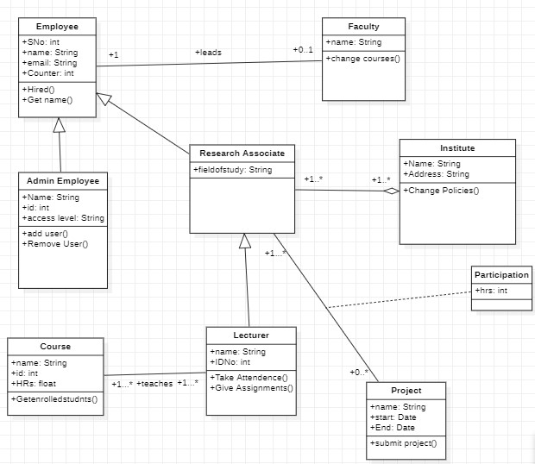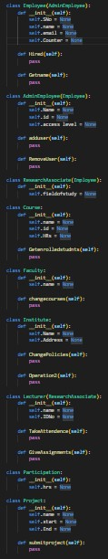

**Project Management System**

Organizations, projects, team, employee and employee roles in teams. An organization relates to zero or more projects, zero or more teams and zero or more people who are employee of the organization. A project related to a single organization and to a single team. A team relates to a single organization to a single project. A person relates to a single organization that is an employer. A team relates to a zero or more people as member of the team in which a person plays a role. A person relates to a single team in which a person plays a role.

A project has name that is a string, a start and end date that are strings, a budget that is a real number and an operation to ensure that the start date and end date of a project are valid. Each team and organization has a name that is a string. A person has an identification number that is an integer, a name that is string, hours that they are available to work, and an operation to determine whether the number of hours that they are available to work, and an operation to determine whether the number of hours that they are available to work is within the range of minimum and maximum number of hours. The relationship between a person and a team defines the title as a string of the role that the person plays on the team. All the attributes and operations are public, but a project’s start date, end date and the hours they are available to work are private

# Student Task

From the above example of Project Management System, analyze the system description draw Class with the help of given explanations.

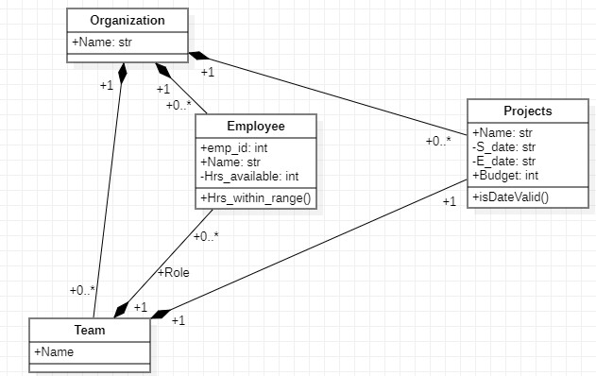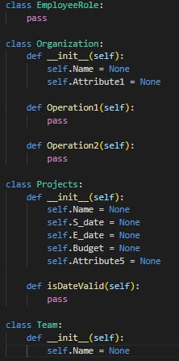

# Submission System

UML diagrams are generally used to describe software systems, such as the student administration system of a university, at which we have looked in this book from various aspects. Creating a continuous, de• tailed model of the entire system which could actually be implemented in executable code would go beyond the scope of this book. However, we will again extract a part of the system to illustrate the interaction of the different diagrams. To this end, we will look at a submission system that is to be used to manage submissions, that is, the students' papers for assignment tasks. The requirements for this system are as follows:

* Every course in the system has lecturers assigned to it. This is done by one of the course administrators, who is also a lecturer. As part of a course, lecturers may create tasks and assess papers submitted by students. Therefore, the lecturers award points and give feedback.
* The course administrator defines which lecturer assesses which papers. At the end of the course, the course administrator also arranges for certificates to be issued. A student's grade is calculated based on the total number of points achieved for the submissions handed in.
* Students can take courses and upload papers.
* All users-students and lecturers-can manage their user data, view the courses and the tasks set for the courses (provided the respective user is involved in the course), and view submitted papers as well as grade points. However, students can only view their own papers and the related grades. Lecturers can only view the papers assigned to them and the grades they have given. The course administrator has access rights for all data.
* A course is created and deleted by an administrator.
* When a course is created, at least one administrator must be assigned to it. Further course administrators can be assigned at a later point in time or assignments to courses can be deleted. The administrator can also delete whole courses.
* Information about users and administrators is automatically transferred from another system. Therefore, functions that allow the creation of user data are not necessary.
* All of the system functions can only be used by persons who are logged in.

## Student Task

From the above example of Submission System, analyze the system description draw Use Case and Class, with the help of given explanation

